Software Design Document (SDD)
for
Car Taxi Management System

Version: 1.0
Date: August 4, 2025

1. System Architecture

1.1. Architectural Style
The system is designed using a Client-Server Architecture with a clear separation of concerns between the frontend and backend.
- Client (Frontend): A Single-Page Application (SPA) developed using React.js. It is responsible for rendering the user interface, handling user interactions, and communicating with the server. It will run on port 8081.
- Server (Backend): A RESTful API developed using Spring Boot. It is responsible for business logic, data validation, persistence, and serving data to the client. It will run on port 8080.
- Communication Protocol: The client and server communicate asynchronously over the HTTP protocol. Data is serialized and exchanged in JSON format.

2. Frontend Design (React.js)

2.1. Component Design
The frontend is built with a modular, component-based structure.
- App.js: The root component that configures the client-side routing using react-router-dom to manage navigation between different views.
- components/NavBar.jsx: A presentational component that renders the main navigation bar, including the application title and navigation links (<Link>).
- components/Home.jsx: A component for the landing page, displaying a welcome message and a link to the driver registration page.
- components/AddDriver.jsx: A smart component containing the driver registration form. It manages its own state for form fields, handles user input, performs validation, and orchestrates the API call to submit the form data.
- components/ViewDriver.jsx: A smart component responsible for fetching the list of all drivers from the backend API when the component mounts and rendering the data within an HTML table.
- components/Footer.jsx: A simple, static component that renders the application footer.

2.2. State Management
Local component state, managed via the useState hook, will be used for form inputs, error messages, and UI loading indicators.

2.3. API Communication
The native browser fetch API will be used to handle all asynchronous HTTP requests to the backend REST API.

3. Backend Design (Spring Boot)

3.1. Package Structure
The backend follows a standard layered architecture to promote separation of concerns and maintainability.
- com.examly.springapp.controller: Contains REST Controllers that map HTTP requests to service methods.
- com.examly.springapp.model: Contains JPA entity classes that model the database tables.
- com.examly.springapp.repository: Contains Spring Data JPA interfaces for database operations.
- com.examly.springapp.service: Contains service classes that encapsulate the core business logic.
- com.examly.springapp.exception: Contains custom exception classes for specific error scenarios.
- com.examly.springapp.configuration: Contains configuration classes, such as CORS settings.

3.2. Class Design
- Driver.java (Model): A JPA entity annotated with @Entity. It maps to the driver database table and contains fields like driverId, driverName, city, phone, etc., with appropriate annotations (@Id, @GeneratedValue).
- DriverRepo.java (Repository): An interface that extends JpaRepository<Driver, Integer>, providing full CRUD functionality for the Driver entity.
- DriverService.java (Service): This class is annotated with @Service and injected with DriverRepo. It implements the business logic for methods like addDriver(Driver driver) and getAllDrivers().
- DriverController.java (Controller): This class is annotated with @RestController. It defines the API endpoints and maps them to service methods.
- InvalidPhoneException.java / InvalidLicenseException.java (Exception): Custom runtime exceptions extending RuntimeException to handle specific data validation errors on the server side.
- TaxiAppCorsConfiguration.java (Configuration): A configuration class implementing WebMvcConfigurer. It overrides the addCorsMappings() method to globally enable cross-origin requests from the React frontend's origin (http://localhost:8081).

4. Database Design

4.1. Schema Definition
The system will use a single relational database table named driver. The schema is defined as follows:

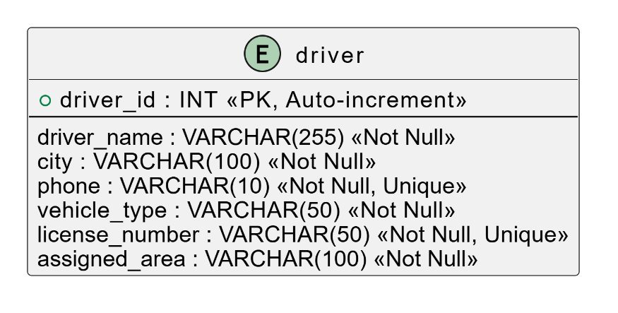
5. API Specification

5.1. POST /addDriver
- Description: Adds a new driver to the system.
- Method: POST
- Headers: Content-Type: application/json
- Request Body (Sample):
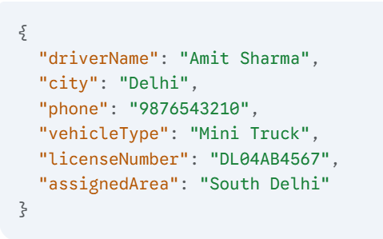
- Success Response:
  - Code: 200 OK
  - Content: The newly created Driver object, including its database-generated driverId.
- Error Response:
  - Code: 500 Internal Server Error

5.2. GET /getAllDrivers
- Description: Retrieves a list of all registered drivers.
- Method: GET
- Headers: Accept: application/json
- Request Body: None
- Success Response:
  - Code: 200 OK
  - Content (Sample):
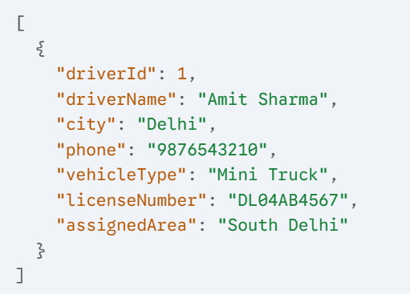
- Error Response:
  - Code: 404 Not Found (If no drivers exist, though returning 200 OK with an empty array is also a common practice).

